Elton, Gruber, Brown, and Goetzmann
Modern Portfolio Theory and Investment Analysis, 9th Edition
Solutions to Text Problems: Chapter 8

Chapter 8: Problem 1
Given the correlation coefficient of the returns on a pair of securities i and j, the securities’ covariance can be expressed as the securities’ correlation coefficient times the product of their standard deviations:
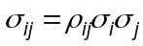
But if we assume that all pairs of securities have the same constant correlation, 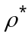, then the constant-correlation expression for covariance is:
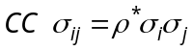

Given the assumptions of the Sharpe single-index model, the single-index model’s expression for the covariance between the returns on a pair of securities is:
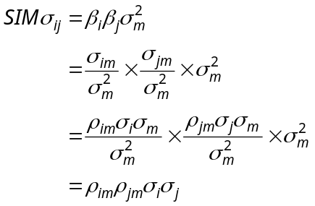
If the assumptions of both the constant correlation and single-index model hold, then we have 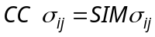:
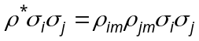 or 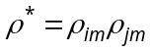

This must hold for all pairs of securities, including i and j, i and k and j and k. So we have:
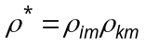
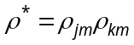
The only solution to the above set of equations is:
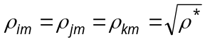
Therefore, for any security i we have:
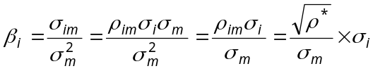
In other words, given that all pairs of securities have the same correlation coefficient and that the Sharpe single-index model holds, each security’s beta is proportional to its standard deviation, where the proportion is a constant across all securities equal to 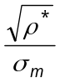.

Chapter 8: Problem 2

Start with a general 3-index model of the form:

(1)

Set 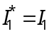 and define an index I₂ which is orthogonal to I₁ as follows:

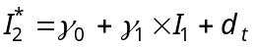 or 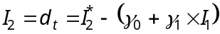

which gives:

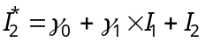

Substituting the above expression into equation (1) and rearranging we get:

The first term in the above equation is a constant, which we can define as 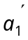. The coefficient in the second term of the above equation is also a constant, which we can define as 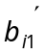. We can then rewrite the above equation as:

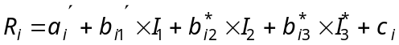 (2)

Now define an index I₃ which is orthogonal to I₁ and I₂ as follows:

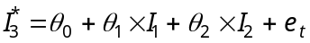 or 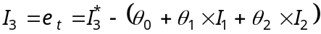

which gives:

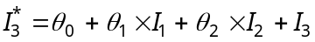

Substituting the above expression into equation (2) and rearranging we get:

In the above equation, the first term and all the coefficients of the new orthogonal indices are constants, so we can rewrite the equation as:

Chapter 8: Problem 3

Recall from the earlier chapter on the single-index model that an expression for the covariance of returns on two securities i and j is:

The first term contains the variance of the market portfolio, the second two terms contain the covariance of the market portfolio with the residuals and the last term is the covariance of the residuals.

Given that one of the model’s assumptions is that the covariance of the market portfolio with the residuals is zero and that, from the problem, the covariance of the residuals equals a constant K, the derived covariance between the two securities is:

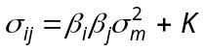

One expression for the variance of a portfolio is:

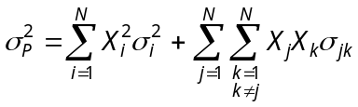

Recalling that the single-index model’s expression for the variance of a security is 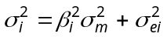 and substituting that expression and the derived expression for covariance into the above equation and rearranging gives:

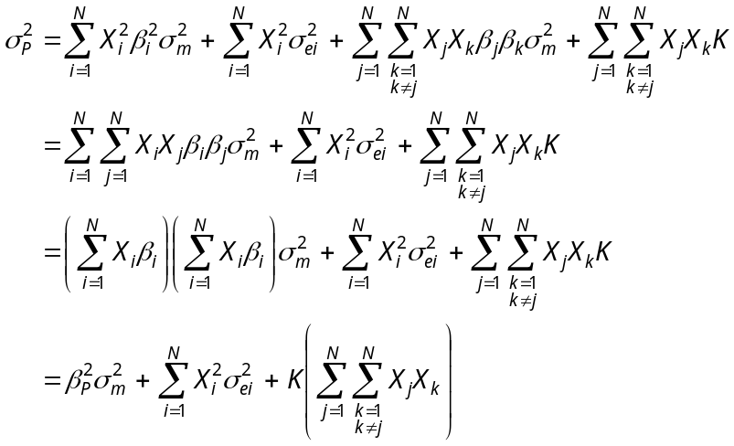

Chapter 8: Problem 4

Using the result from Problem 2, we have:

Since the residual c_{i} always has a mean of zero (by construction if necessary), we have the following expression for expected return:

The variance formula is:

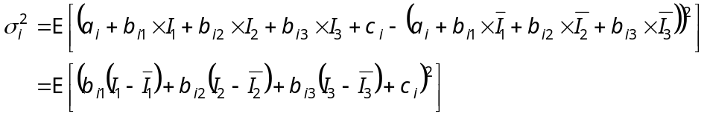

Carrying out the squaring, noting that the indices are all orthogonal with each other and making the usual assumption that the residual is uncorrelated with any index gives us:
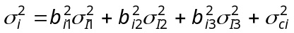

The covariance formula is:

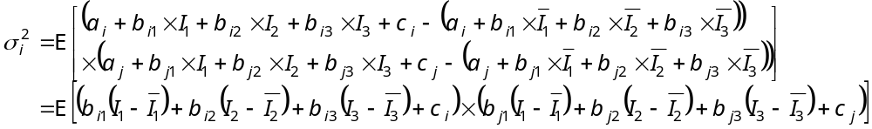

Carrying out the multiplication, noting that the indices are all orthogonal with each other, making the usual assumption that the residuals are uncorrelated with any index and assuming that the residuals are uncorrelated with each other gives us:
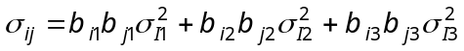

Chapter 8: Problem 5

The formula for a security's expected return using a general two-index model is:

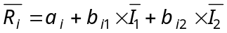

Using the above formula and data given in the problem, the expected return for, e.g., security A is:

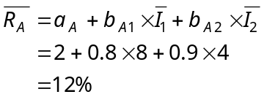
Similarly:

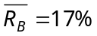; 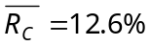

The two-index model’s formula for a security’s own variance is:

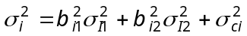
Using the above formula, the variance for, e.g., security A is:

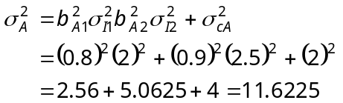

Similarly, σ²_{B} = 16.4025, and σ²_{C} = 13.0525.

C. The two-index model's formula for the covariance of security i with security j is:

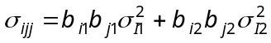

Using the above formula, the covariance of, e.g., security A with security B is:

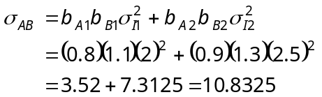

Similarly, σ_{AC} = 9.0675, and σ_{BC} = 12.8975.

Chapter 8: Problem 6

For an industry-index model, the text gives two formulas for the covariance between securities i and k. If firms i and k are both in industry j, the covariance between their securities' returns is given by:

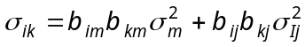

Otherwise, if the firms are in different industries, the covariance of their securities' returns is given by:

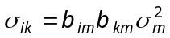

If only firms A and B are in the same industry, then:

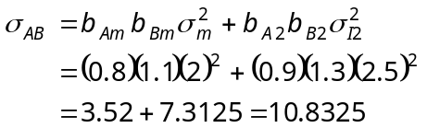

The second formula should be used for the other pairs of firms:

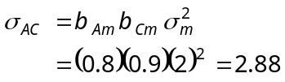

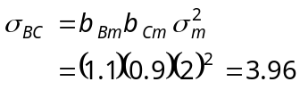

Chapter 8: Problem 7
The other formula should be used for the other pairs of firms:
The answers for this problem are found in the same way as the answers for problem 6, except that now only firms B and C are in the same industry. So for firms B and C, the covariance between their securities' returns is:

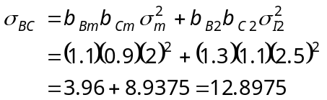

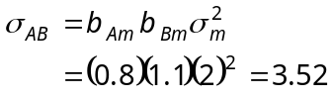

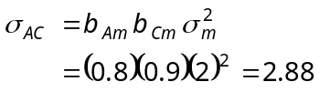

Chapter 8: Problem 8

To answer this problem, use the procedure described in Appendix A of the text. First, I₁ is defined as being equal to I*₁ , then I*₂ is regressed on I₁ to obtain the given regression equation. Since d_{t} is uncorrelated with I₁ by the techniques of regression analysis, d_{t} is an orthogonal index to I₁. So, define I₂ = d_{t}. Then express the given regression equation as:

I*₂ = 1 + 1.3 I₁ + I₂.

Now, substitute the above equation for I*₂ into the given multi-index model and simplify:

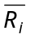 = 2 + 1.1 I*₁ + 1.2 I*₂ + c_{i}

= 2 + 1.1 I₁ + 1.2 (1 + 1.3 I₁ + I₂) + c_{i}

= 2 + 1.1 I₁ + 1.2 + 1.56 I₁ + 1.2 I₂ + c_{i}

= 3.2 + 2.66 I₁ + 1.2 I₂ + c_{i}

The two-index model has now been transformed into one with orthogonal indices I₁ and I₂, where I₁ = I*₁, and I₂ = d_{t} = I*₂ - 1 - 1.3 I₁.

